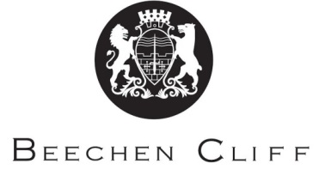

Classical Civilisation A Level 2018

Year 1:
- The World of the Hero
- Imperial Image: Augustan Rome
- Roman Britain

Year 2:
- The World of the Hero continued
- Imperial Image: Augustan Rome continued
- A class choice between Greek Religion, Love and Relationships, Politics of the Late Republic or Democracy and the Athenians

