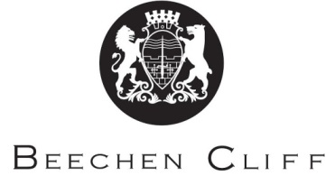

A-Level Overview Year 1: German

Term | Mrs Hall | Mr Hall | Key Skills and grammar
1 | - Comparing types of families  - Modern marriage and partnerships  - Modern family living | - Film: Das Leben der Anderen.  - The digital world:  - The Internet  - Social networks | Translation into English.  Reading for gist.  Writing summaries.  Pronunciation.  Tenses.  Adjective endings.  Cases & prepositions.
2 | - Types of music  - Television  - Celebrities as role models  - Fashion trends | - The digital world:  - Digitalisation of society.  - Culture in Berlin:  - History  - Theatre, music, museums. | Opinions.  Connectives.  Translation.  Persuasive speaking.  Word order.  Imperfect subjunctive.
3 | - Festivals & traditions  - Social & economic importance of festivals | - Culture in Berlin  - Diversity amongst the population. | Translation.  Listening strategies.  Writing summaries.  Revision of tenses.  Passive voice.  Sep/insep verbs.
4 | - Architecture & building styles  - Influence & role of art and artists  - Post-war architecture | - Film: ‘Das Leben der Anderen’  - Re-visit the film in more detail. | Translation.  Presenting.  Answering questions.  Word order in subordinate clauses.  Relative, demonstrative & indefinite pronouns.
5 | - Art and Architecture: Past, present & future.  - Revision | - Film.  - Speaking practice. | Word order.  Analytical language.  Summaries.
6 | Launch Individual Research Project. | Begin work on set book: ‘Der Besuch der alten Dame’.

