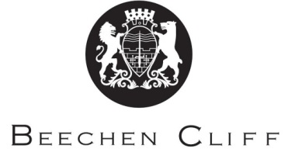

A-Level Overview Year 1: Italian
Term | Miss Pavone | Miss Morra/Miss Zuanella | Key Skills / Coursework / PSAs / Deadlines
1 | Health and Fitness | Youth Culture & Concerns | Regular vocab tests  Regular reading tasks  Essential homework as preparation for classwork e.g. summarise, look up new vocab etc  Regular listening tasks  Undertake research on given topics/tasks  Essay writing
2 | Continue with topic from Term 1 | Continue with topic from Term 1 | As for Term 1
3 | The World Around Us | The World of Work and Education | Key Skills etc as Above.  Begin preparation for speaking exam (prepare to be able to give opinions on the topics covered in class)
4 | Continue with topic from Term 3 | Continue with topic from Term 3 | As for term 3
5 | Finish above topics if necessary. Exam practice and preparation
6 | Finish above topics if necessary. Exam practice and preparation.  Begin A2 after exams: The Risorgimento and the Unification of Italy

