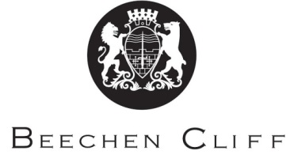

A-Level Overview Year 1: Italian
Term | Miss Pavone | Miss Zuanella | Key Skills / Coursework / PSAs / Deadlines
1 | Theme 1: Changes in Italian Society  The changing Italian family  Changes in attitude towards the family  The ‘mammoni’ | Theme 2: Political and artistic trends in Italian speaking countries and communities  Music: impact on modern culture | Skills focus:  Listening and responding  Reading and responding  Translating into Italian  Summarising a written text in speaking
2 | Literary text/film: Work 1 | Theme 2: Political and artistic trends in Italian speaking countries and communities  The Media: printed and online | Skills focus:  Expressing a point of view  Justifying a point of view  Developing an argument
3 | Literary text/film:  Work 1 | Theme 1: Changes in Italian Society  The education system  Problems students face | Skills focus:  Reaching a logical conclusion  Demonstrating knowledge and understanding about Italian culture and society  Evaluating form and technique in the text/film  Developing logical arguments to persuade
4 | Theme 2: Political and artistic trends in Italian speaking countries and communities  Cultural heritage  Festivals, customs and tradition | Theme 1: Changes in Italian Society  The world of work  Equality between the sexes  New ways of working | Skills focus:  Examination skills for Paper 1/2  Examination skills for Paper 2/3
5 | Revision | Revision
6 | Research project –introduction | Literary text/film | Skills focus:  Studying independently

