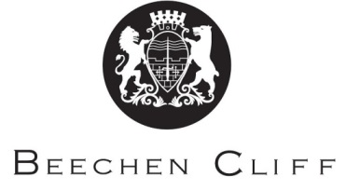

A-Level Overview Year 1: Chemistry
Term | Mr Stewart | Mr Wilkinson / Mr Forrest | Key Skills / Coursework / PSAs / Deadlines
1 | Module 2 Foundations in Chemistry  - 2 : Atoms, ions and compounds  - 3 : Amount of substance | Module 2 Foundations in Chemistry  - 5 : Electrons and bonding  - 6 : Shapes of molecules and intermolecular forces | Use on line Text book resources  Read textbook pages  Review your notes  Answer summary questions / Practice questions
2 | - 4 : Acids and redox  Revision for Mock exam | Module 3 Periodic Table and Energy  - 7: Periodicity  - 8: Reactivity series  Revision for Mock exam | Use on line Text book resources  Read textbook pages  Review your notes  Answer summary questions / Practice questions  REVISION for MOCK EXAM
3 | MOCK EXAM  - 9 : Enthlapy | MOCK EXAM  Module 4 Core organic Chemistry and analysis  - 11 : Basic concepts of organic chemistry  - 12 : Alkanes | Use on line Text book resources  Read textbook pages  Review your notes  Answer summary questions / Practice questions.  PAG Write up
4 | - Reaction Rates and Equilibrium | - 13 : Alkenes  - 14 : Alcohols | Read textbook pages  Review your notes  Answer summary questions / Practice questions.  PAG Write up
5 | - 17 : Spectroscopy  REVISION  YEAR 1 EXAMINATION | - 15 : Halogenoalkanes  - 16 : Organic Synthesis  REVISION  YEAR 1 EXAMINATION | Read textbook pages  Review your notes  Answer summary questions / Practice questions.  PAG Write up  EXAMINATION REVISION
6 | START YEAR 2  - Orders of Reactions | START YEAR 2  - Carboxylic acids and alcohols | Read textbook pages  Review your notes  PAG Write up

