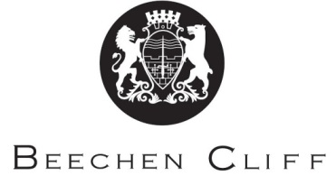

A-Level Overview Year 2: English Literature
Term | CMC  CSD | TW  AHB | Key Skills / Coursework / PSAs / Deadlines
1 | Dubliners:  - Introduction to Modernism  - Background and context  - Study of characters  - Study of themes  - Narrative style | Human Chain:  - Context  - Study of themes  - Poetic devices  - Structure and form | Reading stories and poetry  Research tasks  Essay writing at A Level and learning of AOs
2 | Completion of coursework folder:  - How to compare texts  - Different critical viewpoints  - Drafting and writing final piece | A Doll’s House:  - Realism and theatre styles  - Background and context.  - Close study of play  - Language analysis | Completing reading of texts.  Reading critical viewpoints  Learning key literary terminology and applying in essay tasks
3 | The Age of Innocence:  - Author and genre study  - Close reading of novel  - Context – how it fits into genre of American Literature | The Merchant’s Prologue and Tale/A Doll’s House:  - Revision of The Merchant’s Prologue and Tale  - Comparing the texts  - Exam technique  - Addressing the AOs | Reading of poetry, prose and drama texts  Learning important contextual links  Learning key literary concepts and applying in essay responses
4 | Measure for Measure  - Revise play: context, characters, themes, language analysis  - Re-read critical articles  - How to approach the extract question | The Great Gatsby  - Revise novel: context, characters, themes, language analysis  - Wider critical reading. | Complete re-reading of drama and poetry texts.  Re-reading of critical articles
5 | Synoptic preparation:  - Extract analysis for unseen component.  - Meeting the AOs  - Studying exemplar material | Synoptic preparation:  - Comparison of novels  - Meeting the AOs  - Studying exemplar material | Re-read texts  Study extracts  Timed essay practice  Resources on OCR website

