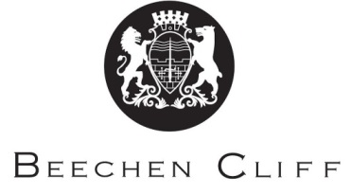

Religion, Philosophy and Ethics A-Level Overview Year 1

Term | Miss Netto | Mrs Baylis | Key Skills / Coursework / PSAs / Deadlines
1 | Ethics  Natural law  Virtue ethics | Philosophy  Teleological argument  Cosmological argument | Read textbook pages  Notes and practical write-ups  Test on Ethics and Philosophy Modules 1 per half term.
2 | Situation ethics  Application of theories to:  Embryo research | Ontological argument  Evil and suffering
3 | Euthanasia  Animal ethics | Religious experience
4 | Sources of wisdom and authority  God, self, death and the afterlife | Good conduct and key moral principles  Religious identity
5 | Revision | Revision
6

A2 Overview Religion, Philosophy and Ethics
Term | Miss Netto | Mrs Baylis | Key Skills / Coursework / PSAs / Deadlines
1 | Philosophy –  Religious language  Miracles | Ethics: Free will and moral responsibility  The conscience | Read textbook pages  Notes and practical write-ups  Test on Ethics and Philosophy Modules 1 per half term.  Complete essay project
2 | Self and life after death | Ethics: Metaethics  Bentham and Kant
3 | Religion and dialogues:  Expression of religious identity  Religion, gender and sexuality  Religion and science | Religion and dialogues: Religion and secularisation, religion and pluralism
4 | Revision | Revision
5 | Revision | Revision
6

