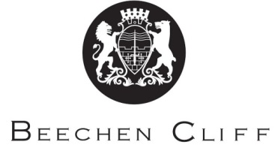

A-Level Overview Year 1: Spanish
Term | Mrs Marshall | Mr Mann/ Mr Bonilla | Key Skills / Coursework / PSAs / Deadlines
1 | Cyberspace  - Internet  - Mobiles  - Social media | Traditional and modern values  - Families  - Marriage/divorce  - Catholic church | Consolidation of all tenses and grammar learnt at GCSE
2 | The influence of idols  - Singers and musicians  - TV and film stars  - Role-models | Sexual equality  - Women and work  - Machismo and feminism  - Rights of LGBT | Translation skills  Summary skills
3 | Study of a film  - Plot  - Characters  - themes | Regional identity  - Customs  - Food  - languages | Mock exam Jan  Essay writing skills
4 | Study of a film  - social environment  - techniques  - style | Cultural Heritage  - historic sites and pre-columbian civilisations  - art and architecture  - music and dance | Preparation for mock speaking exam to be held last week of term
5 | Revision and consolidation | Revision and consolidation | Speaking exam early May
6 | Aspects of political life | Individual research project

