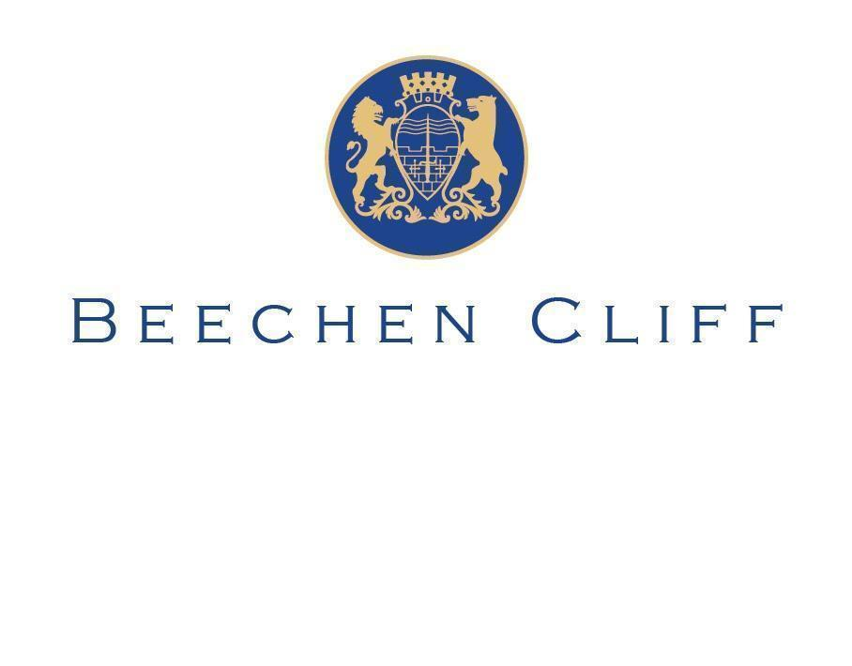

**A level History**

**Curriculum Booklet**

**2024 - 2025**

**Head of Subject: Ms Mhairi Sinclair**

**Subject Curriculum Intent:**

Building on the KS3 and KS4 curriculum, the A-level programme of learning is designed to completely embed both students’ knowledge of History as well as their History skills and their wider competences as lifelong learners. Enhancing students’ confidence in exploring and evaluating primary source material and historical interpretations is central to navigating the blizzard of data, opinion and propaganda which engulfs modern society. Similarly, understanding the impact of past events on the ‘big picture’ of human progress, stasis and regress is essential for appreciating the fundamentals of modern civilisation. The intention of encouraging students to explore and evaluate contemporary political, economic, social and cultural issues permeates every learning activity. MSC issues are explored at both local and international scales. In carefully developing their knowledge and skills at A level, this curriculum is also a platform for progression to further specialist study of History at degree level.

As a Sixth Form with high levels of above-average prior attainment, our curriculum is designed to be both engaging and challenging. It goes beyond the requirements of the AQA specification, broadening the range of knowledge and skills students develop and encouraging wider reading of contemporary authors such as Susannah Lipscombe and Max Hastings. Pupils have the exciting opportunity to immerse themselves in the Oxford University lecture series on Tudor Rebellions. At the same time our curriculum is designed to be inclusive for all by supporting learners to achieve their full potential regardless of background and starting point. Whether through essay writing or data analysis and manipulation workshops, our curriculum is designed to help students synthesise and articulate their learning effectively to others.

Our curriculum is designed to ensure that students develop a knowledge of how History relates to social, moral, spiritual and cultural issues. It helps students understand why the World is shaped as it is today. One cannot understand the recent Ukrainian crisis without first looking at the emergence of the Cold War. Pupils understand why those in power have made certain decisions and what that means for the people below. Ultimately in this sense our curriculum allows students to become more active and compassionate citizens.

We want our students to recognise that Historians are highly employable people due not only to the knowledge and skills they develop but also because of the synoptic understanding of the world they have. Pupils are exposed to a broad range of History, from Early Modern and the Tudor time period to the 20th Century with the Cold War. This means that our students are extremely prepared for a University degree as they have been exposed to a broad range of topics.

**Subject Curriculum Implementation:**

The curriculum at KS5 builds on the knowledge and understanding students have amassed during their study of History in KS3 and KS4. We have chosen The Tudors and Cold War topics as many of our students have studied both topics at GCSE, with Elizabethan England and the Vietnam and Korea Wars. Over the course of the two years of A level, students will gain a deeper understanding of the past through political, social, economic, and cultural perspectives. Students will engage with two historical topics which will provide them with the knowledge and skills required to be a successful historian.

Challenge is a key aspect of KS5 History, all students are encouraged and pushed to go beyond their comfort zone. In order to achieve this, we promote academic reading and writing and test pupils on various interpretations of History. Reading lists are shared with students in the lead up to their non-examined assessment and there is opportunity to visit Bath Spa University library to learn how to professionally reference.

Personal Learning Checklists (PLCs) are given to students at the start of every topic to allow them to compare their initial knowledge and understanding at the start with what they have gained at the end. As well as aiming to create excellent historians, we focus on teaching students a combination of content and knowledge with technique and application so they are able to do their best in assessments and examinations. Knowledge organisers are provided to pupils where a knowledge test will follow several weeks later, this helps pupils with their retrieval practice, ready for the end of year summer exams.

There is a 2.5 hour exam for both the Cold War and Tudor module. This equates to 80% of pupils' final grade. The Tudor exam will include an interpretation question whether the Cold War module will have a source question. Both exams will have various ‘essay style’ questions to choose from that will be 25 marks.

**Allocated Curriculum Time:**

|  | **Lower Sixth** | **Upper Sixth** |
| --- | --- | --- |
| **Fortnightly lesson allocation** | 8 hours plus  1 Hour Independent study | 8 hours plus  I Hour Independent study |

**Course Information**

**Exam Board: AQA**

**Specification: 1C, The Tudors 1485-1603 and 2R, The Cold War 1945-1991**

**Lower Sixth**

| **Term** | **Curriculum Foci Areas** | **Assessment** |
| --- | --- | --- |
| **1** | **The Tudors, 1485-1603**  **Course overview – the big picture**  **Henry VII, 1485–1509**   * Henry Tudor’s consolidation of power: character and aims; establishing the Tudor dynasty * Government: councils, parliament, justice, royal finance, domestic policies * Economic development: trade, exploration, prosperity and depression   **The Cold War, 1945-91**  **Course overview – the big picture**  **The Origins of the Cold War, c1945–1949**   * US, British and USSR relations in 1945: conflicting ideologies. * Developing tensions: the Soviet Union occupation/control of eastern and southern Europe.   **Key Skills**   * **Analysing the usefulness of a source** * **Analysing the convincingness of an interpretation** * **Essay writing skills** | End of Topic Assessment at the end of each term. |
| **2** | **The Tudors, 1485-1603**  **Henry VII, 1485–1509**   * Relationships with Scotland and other foreign powers; securing the succession; marriage alliances * Society: churchmen, nobles and commoners; regional division; social discontent and rebellions * Religion; humanism; arts and learning   **The Cold War, 1945-91**  **The Origins of the Cold War, c1945–1949**   * The USA’s involvement in Europe. * Conflict over Germany: developments within the sectors, including Bizonia and currency reform; the Berlin blockade; the creation of East and West Germany; formation of NATO   **Key Skills**   * **Analysing the usefulness of a source** * **Analysing the convincingness of an interpretation** * **Essay writing skills** | End of Topic Assessment at the end of each term. |
| **3** | **The Tudors, 1485-1603**  **Henry VIII, 1509–1547**   * Henry VIII: character and aims; addressing Henry VII’s legacy * Government: Crown and Parliament, ministers, domestic policies including the establishment of Royal Supremacy * Relationships with Scotland and other foreign powers; securing the succession   **The Cold War, 1945-91**  **The Widening of the Cold War, 1949–1955**   * US containment in action in Asia. * The Korean War. * Increasing Cold War tensions: McCarthyism in the USA and its influence in Britain and Europe. * Alliances and shifts: FRG and NATO; the Warsaw Pact; SEATO; Eisenhower, Dulles and 'brinkmanship'; the domino theory; attitude to French struggle in Indo-China; the Geneva Conference   **Key Skills**   * **Analysing the usefulness of a source** * **Analysing the convincingness of an interpretation** * **Essay writing skills** | End of Topic Assessment at the end of each term. |
| **4** | **The Tudors, 1485-1603**  **Henry VIII, 1509–1547**   * Society: elites and commoners; regional issues and the social impact of religious upheaval; rebellion * Economic development: trade, exploration, prosperity and depression * Religion: renaissance ideas; reform of the Church; continuity and change by 1547   **The Cold War, 1945-91**  **The Global War, 1955–1963**   * Khrushchev and East-West relations * Cold War rivalries: the extension of the arms race * Conflict in Asia: Indo-China under Ho Chi-Minh in the North and Diem in the South * Confrontation between the superpowers: US attitudes to Cuba and developments leading to the missile crisis   **Key Skills**   * **Analysing the usefulness of a source** * **Analysing the convincingness of an interpretation** * **Essay writing skills** | End of Topic Assessment at the end of each term. |
| **5** | **NEA coursework introduction**   * Pupils research various topic and choose a suitable title for their coursework |  |
| **6** | **NEA coursework continued**   * Independent Enquiry drafting/writing |  |

**Upper Sixth**

| **Term** | **Curriculum Foci Areas** | **Assessment** |
| --- | --- | --- |
| **1** | **The Tudors, 1485-1603**  **'The Mid-Tudor Crisis', 1547–1563**   * Edward VI, Somerset and Northumberland; royal authority; problems of succession; relations with foreign powers * The social impact of religious and economic changes under Edward VI; rebellion; intellectual developments; humanist and religious thought * Mary I and her ministers; royal authority; problems of succession; relations with foreign powers   **The Cold War, 1945-91**  **Confrontation and cooperation, c1963–1972**   * Confrontation in the Vietnam War * Nixon's policies in Vietnam * Cooperation: attitudes of Khrushchev and Kennedy * Pressures on USSR   **Key Skills**   * **Analysing the usefulness of a source** * **Analysing the convincingness of an interpretation** * **Essay writing skills** | End of Topic Assessment at the end of each term. |
| **2** | **The Tudors, 1485-1603**  **'The Mid-Tudor Crisis', 1547–1563**   * The social impact of religious and economic changes under Mary I; rebellion; intellectual developments; humanist and religious thought * Elizabeth I: character and aims; consolidation of power, including the Act of Settlement and relations with foreign powers * The impact of economic, social and religious developments in the early years of Elizabeth's rule   **The Cold War, 1945-91**  **The Brezhnev era, 1972–1985**   * The USA and SE Asia * The extent of Détente up to 1979 * The Second Cold War * Developments in Africa and the Americas   **Key Skills**   * **Analysing the usefulness of a source** * **Analysing the convincingness of an interpretation** * **Essay writing skills** | End of Topic Assessment at the end of each term. |
| **3** | **The Tudors, 1485-1603**  **The triumph of Elizabeth, 1563–1603**   * Elizabethan government: court, ministers and parliament; factional rivalries * Foreign affairs: issues of succession; Mary, Queen of Scots; relations with Spain * Society: continuity and change; problems in the regions; social discontent and rebellions   **The Cold War, 1945-91**  **The ending of the Cold War, 1985–1991**   * Gorbachev and the ending of the Cold War: pressures on and significance of Gorbachev as Soviet leader; new thinking and practicalities: the importance of Soviet economic problems * The summits between the USA and the USSR, including Geneva, Reykjavik, Washington and Moscow; Reagan; star wars; Bush and the US response   **Key Skills**   * **Analysing the usefulness of a source** * **Analysing the convincingness of an interpretation** * **Essay writing skills** | End of Topic Assessment at the end of each term. |
| **4** | **The Tudors, 1485-1603**  **The triumph of Elizabeth, 1563–1603**   * Economic development: trade, exploration and colonisation; prosperity and depression * Religious developments, change and continuity; the English renaissance and ‘the Golden Age’ of art, literature and music * The last years of Elizabeth: the state of England politically, economically, religiously and socially by 1603   **The Cold War, 1945-91**  **The ending of the Cold War, 1985–1991**   * The collapse of Communism in the Eastern European soviet satellite states; the end of the Brezhnev Doctrine and significance of events of 1989 * The ending of Cold War tensions in Asia: Afghanistan; the Americas: Cuba, Nicaragua and El Salvador; Africa: Angola and Ethiopia; the end of the Cold War: the Malta summit and its aftermath, including the reunification of Germany; the collapse of the USSR and resignation of Gorbachev   **Key Skills**   * **Analysing the usefulness of a source** * **Analysing the convincingness of an interpretation** * **Essay writing skills** | End of Topic Assessment at the end of each term. |
| **5** | **Revision and Exams** |  |
| **6** | **Exams** |  |

**Reading List**

**1C, The Tudors 1485-1603**

* D Murphy (ed), England 1485-1603, Collins, 1999
* N Fellows, Disorder and Rebellion in Tudor England, Hodder, 2009
* R Lockyer & D O’Sullivan, Tudor Britain 1485-1603, Longman, 1993
* K Randall, Henry VIII and the Government of England, Hodder, 2001
* K Randall, Henry VIII and the Reformation in England, Hodder, 2001
* J Warren, Elizabeth I: Meeting the Challenge, Hodder, 2008

**2R, The Cold War 1945-1991**

* G S Barrass, The Great Cold War, Stanford University Press, 2009
* R Croackatt, The Fifty Years War, Routledge, 1995
* John Lewis Gaddis, The Cold War, Penguin, 2007
* Isaacs and Downing, The Cold War: For Forty-five Years the World Held its Breath, Abacas, 2008
* B Lightbody, The Cold War (Questions and Analysis in History), Routledge, 1999
* J Mason, The Cold War: 1945-1991 (Lancaster Pamphlets), Routledge, 1996
* T Judt, Postwar: A History of Europe Since 1945, Vintage, 2010

**Studying/Revision Information**

**Ongoing Studying and Revision**

Central to history is the idea of chronology. It is key for both topics to understand the broad story running through both topics. A good studying technique is to start every topic by making yourself a time-line of important events and testing yourself on them, you instantly give your A-Level History revision a massive boost. Looking at past exam questions is crucial. This will help you to feel comfortable with the format of the papers you take and trying out some timed exam questions is fantastic preparation. Wider reading of the topics is also going to be crucial, particularly for those pupils who want to hit those A/A* grades. Make note of how historian’s opinions differ on the same event and research why you think that might be. Lastly, keeping a well organised folder is going to be essential to help you revise KS5 History. File dividers help you split your notes into the various topics and it allows revision to become a breeze!

**Final Assessment Structure:**

| **Component** | **Weighting**  **(%)** | **Content** | **Proposed Examination Date** |
| --- | --- | --- | --- |
| 1C - The Tudors | 40% | * Henry VII- Henry VIII * Edward, Mary and Elizabeth | May/June of Upper Sixth |
| 2R - The Cold war | 40% | * Cold war 1945-1963 * Cold war 1963- 1991 | May/June of Upper Sixth |
| NEA (Non examined assessment) | 20% | * The choice is up to you! | Hand in 1st December of Upper Sixth |

Please see Exam Board websites for up to date information: <https://www.aqa.org.uk/subjects/history/as-and-a-level/history-7041-7042>